**ASE LAB EXPERIMENT -2**

**Weather forecast**

The present weather details and the future details are also displayed based on the apis from the urls provided below

Weather details at that time:

https://api.openweathermap.org/data/2.5/"weather?"+"q="+ Details.CountryName + "&APPID=" + this.APIkey

weather details based on hourly forecast:

https://api.openweathermap.org/data/2.5/"forecast?"+"q="+ Details.CountryName + "&APPID=" + this.APIkey

For this one weather component is created to give the inputs of the city name and code

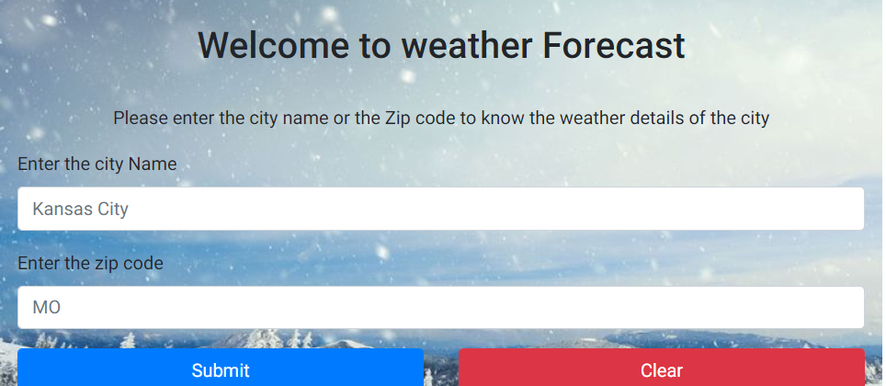

After clicking the submit button

This gives the details from the weather api.

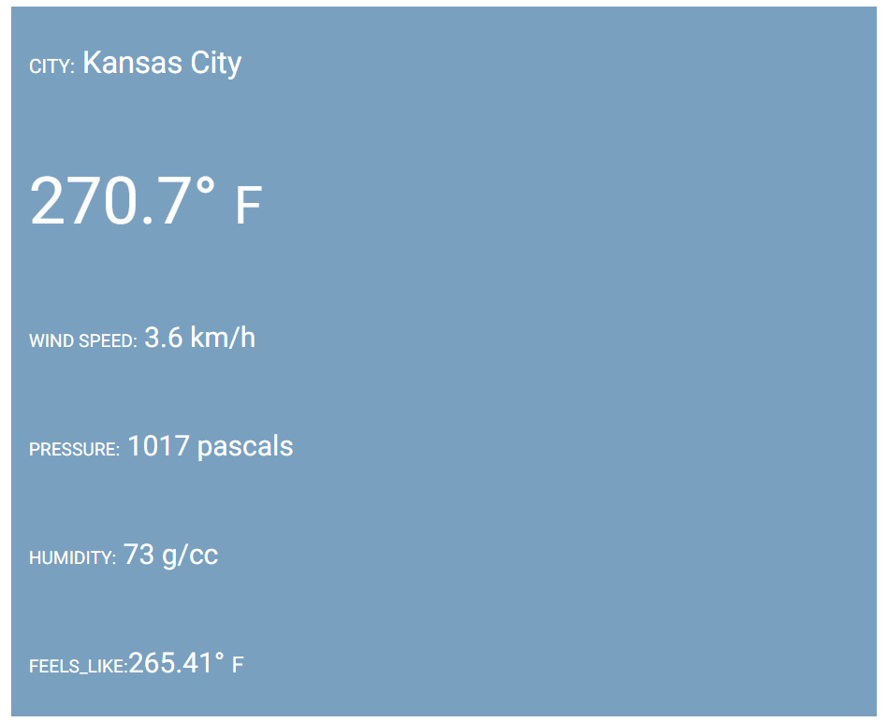

The hourly forecast temperatures are compared using canvas graphs from canvas.min.js

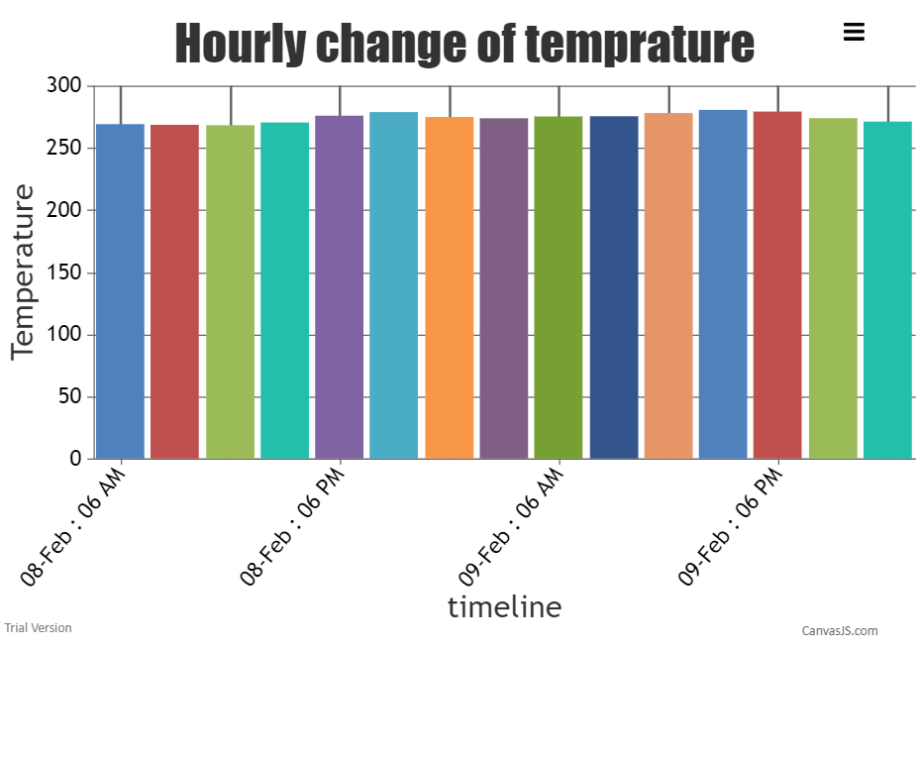

Using the canvas container the details are displayed by taking temp on y axis and dates on xaxis

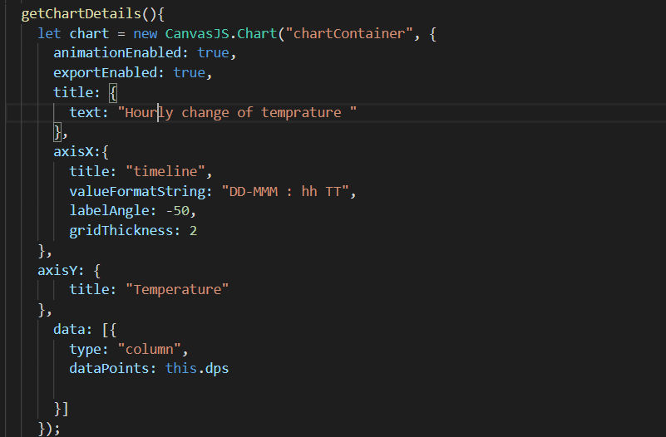

The other hourly forecast details are displayed in the form of a carousel using ng carousel which is displayed in the form of a slide show

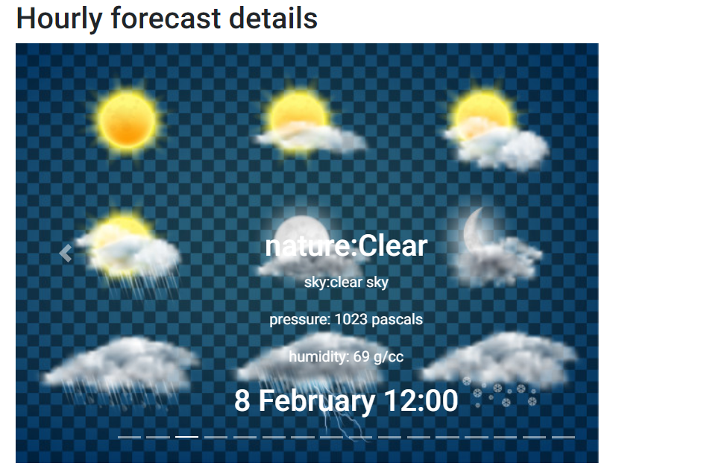

The entire page is designed responsively in bootstrap so that it can be used both for mobiles as well as desktops.

